**DAY -2 TASK**

**DOCKER VERSION**

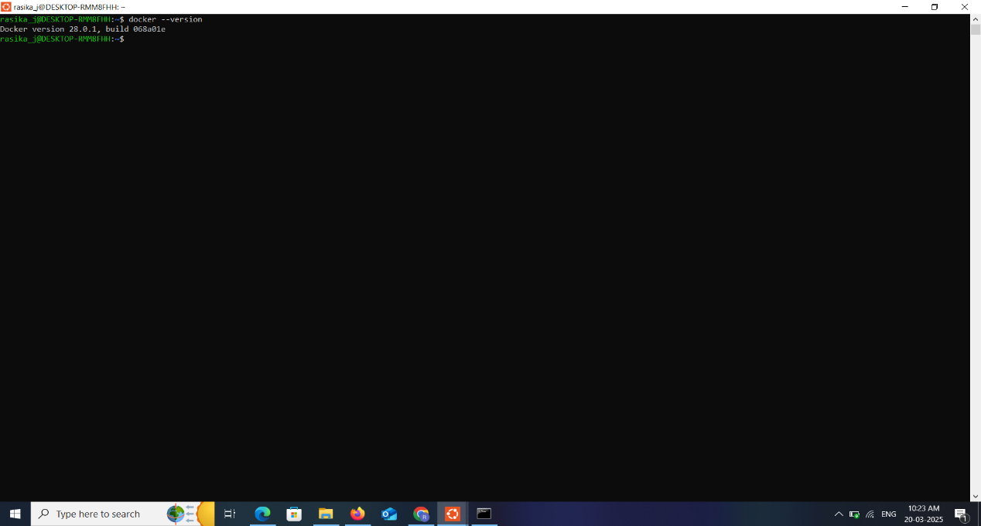

**CONSOLE OUTPUT**

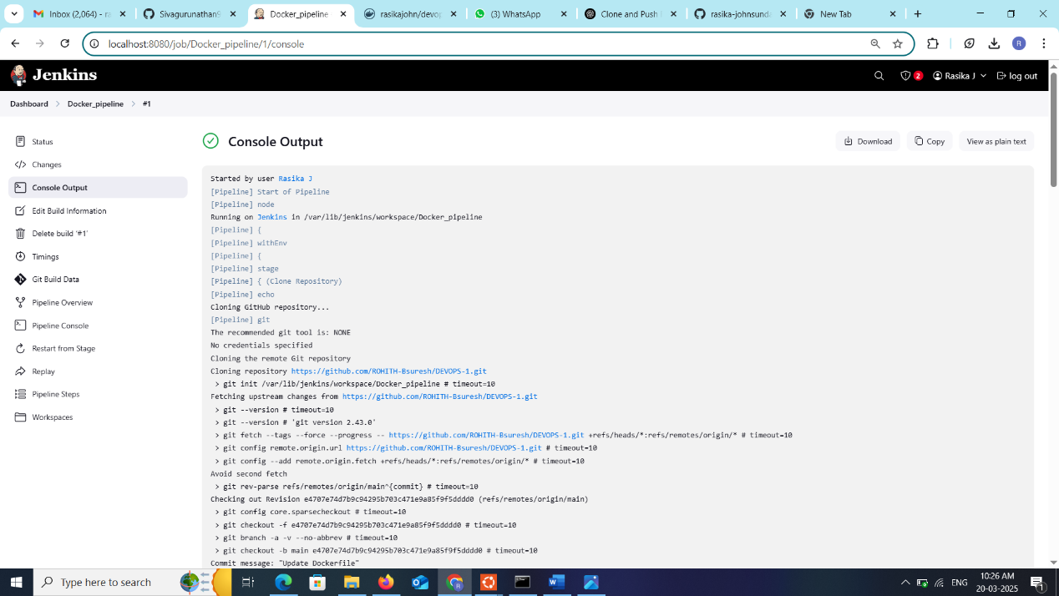

**DOCKER HUB**

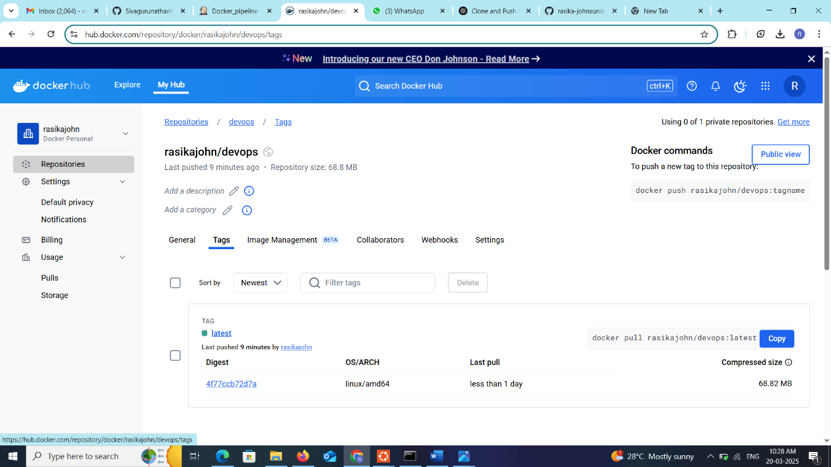

**DOCKER PIPELINE STATUS**

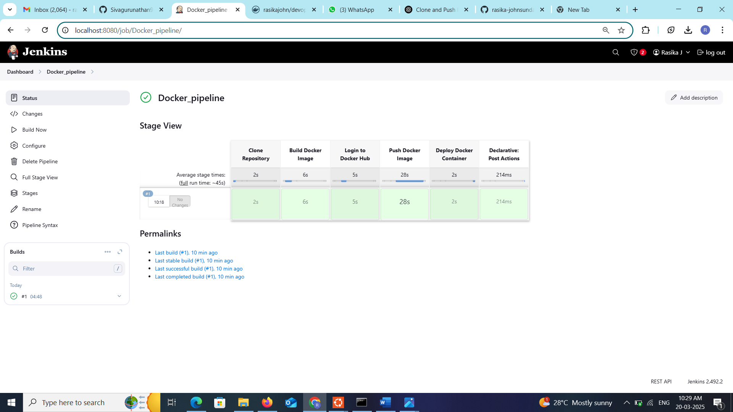

**BUILD DOCKER PIPELINE**

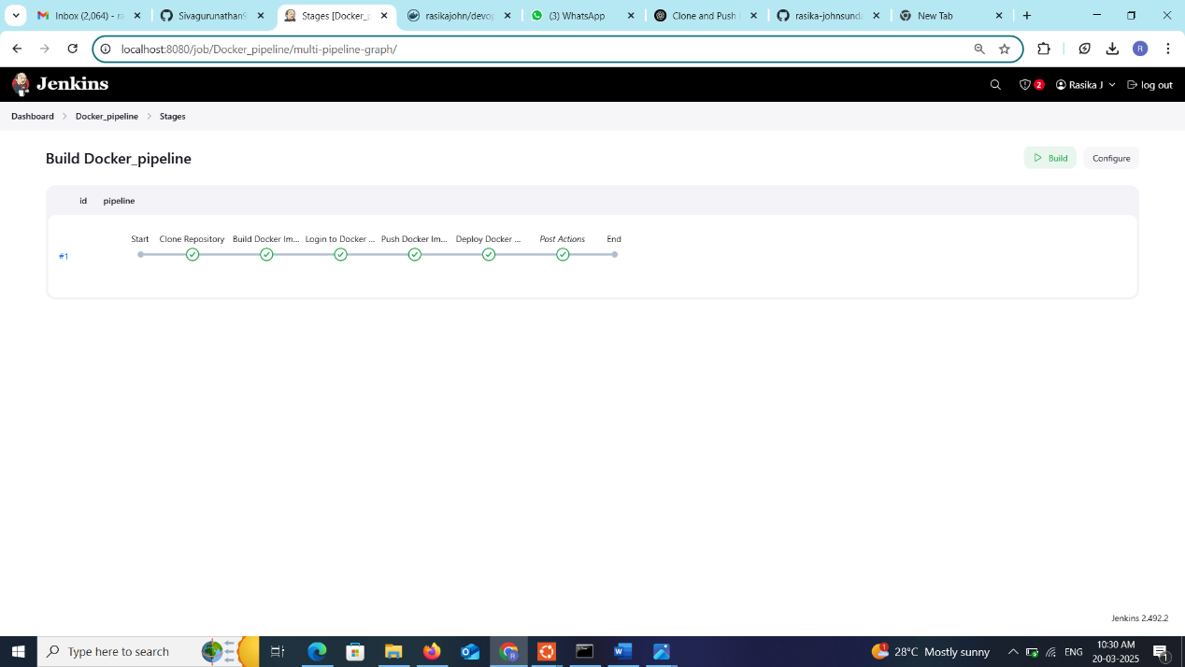

**TASK-3 – OUTPUT**

